FVID Glassdoor Team. Glassdoor company review analysis.

Semiconductor Sector Glassdoor Reviews  
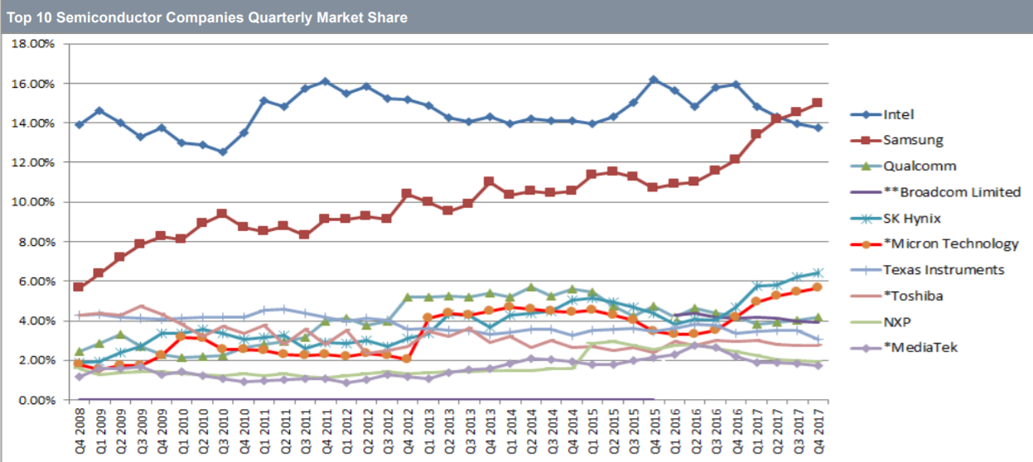  
Figure 1 : Top 10 Semiconductor Companies Quarterly Market Share  
(http://theconfab.com/wp-content/uploads/P-18-Len-Jelinek.pdf)

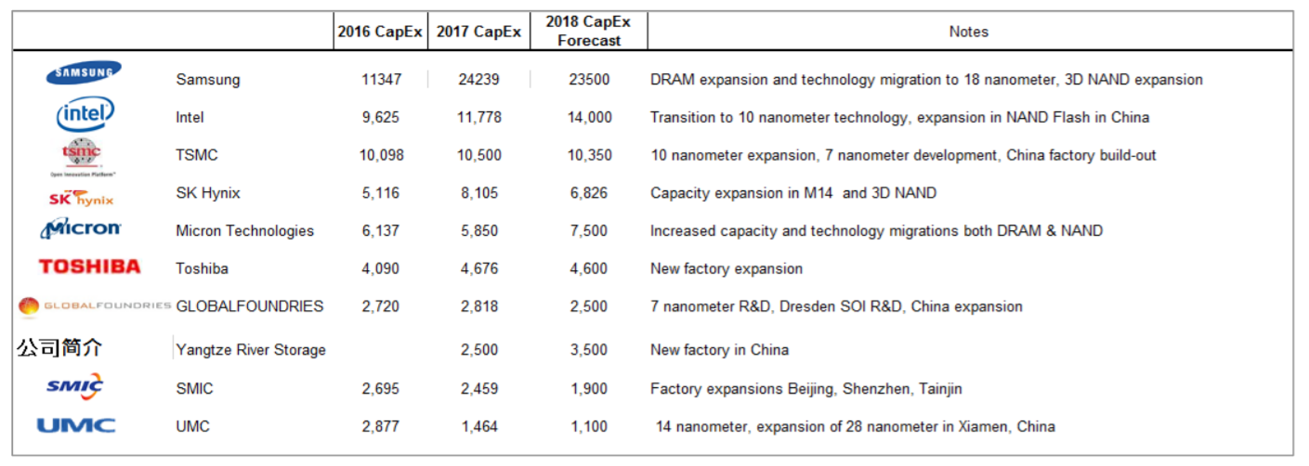

Figure 2 : Investments in Memory and Advanced CMOS Technology   
(http://theconfab.com/wp-content/uploads/P-18-Len-Jelinek.pdf)

1. Toshiba (Overall Rating : 3.3, 901 Reviews)

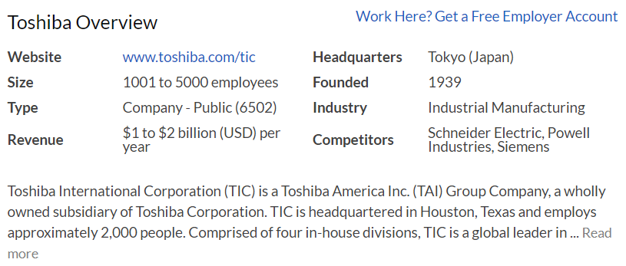

Pros

* 1. Great colleague and environment to work with
  2. Get max incentives almost every year.

Cons

* 1. Less care on the employees and their products
  2. Strong Japanese culture where Japanese are more respected and possess more control on the decision-making process.
  3. Their products are unable to compete with modern technology

Insight

Requires better workload distribution or compensation in order to increase the work life balance quality.

Japanese culture may threaten the existing employees to leave the company. More management from different location may require diversifying the management with authority and increase fair opportunity for promotion.

1. Qualcomm (Overall Rating : 3.8, 5500 Reviews)

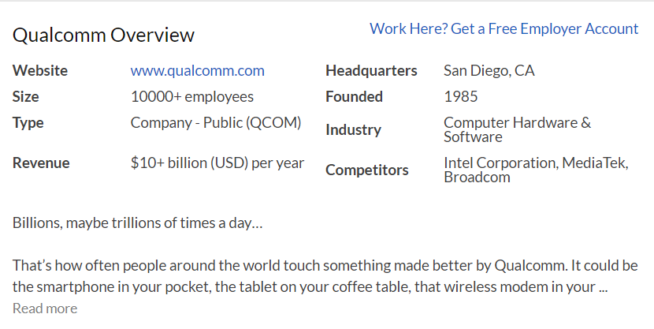

Pros

* 1. Great opportunity to work with the most advanced technology
  2. Flexible working hours
  3. Great benefits and welfare provided

Cons

* 1. Observable bureaucracy
  2. Too many managers within the company
  3. Poor stock performance

Insight

Management and Engineering team coordination is poor thus require better communication / workshop to match the understandings of two different parties. Require more hiring of engineers to be innovative.

Currently undergoing a change in the company’s culture. If this continues it will slow down the promotion due to bureaucracy and politics.

1. TSMC (Overall Rating : 3.7, 428 Reviews)

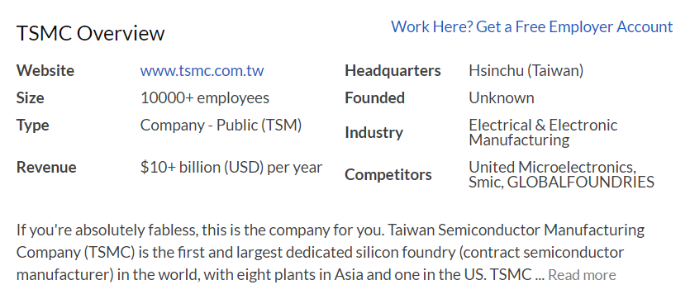

Pros

* 1. Good training and great colleagues to work with
  2. Good salary and bonus

Cons

* 1. Bad work life balance (competitive and stressful daily work)
  2. Little chance of career growth (Conservative company culture)

Insight

Little chance of career growth was noticeable if the employee was not Taiwanese/Chinese.

Taiwan possess great potential in the semi-conductor industry. Companies such as MSI, Acer, Asus, ASrock and Gigabyte. These companies mainly build computer hardware implementing semiconductor products. Great opportunity available for TSMC.

1. Texas Instruments (Overall Rating : 4.0, 2700 Reviews)

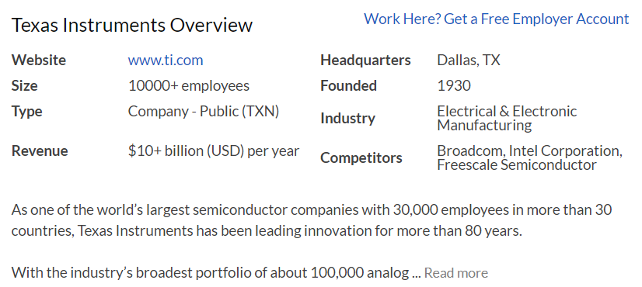

Pros

* 1. Good training and great colleagues to work with
  2. Good work culture and relaxed environment
  3. Decent pay

Cons

* 1. Weak performance in the unstable semiconductor market
  2. Bad work life balance

Insight

There exists a cultural gap between the mid-level managers and the newcomers. Require more conversation and workshop activities to strengthen the bonding within the company.

Need to set up satisfiable compensation for employees who work overtime

1. SMIC (Semiconductor Manufacturing International Corporation)

(Overall Rating : 3.2, 36 Reviews)

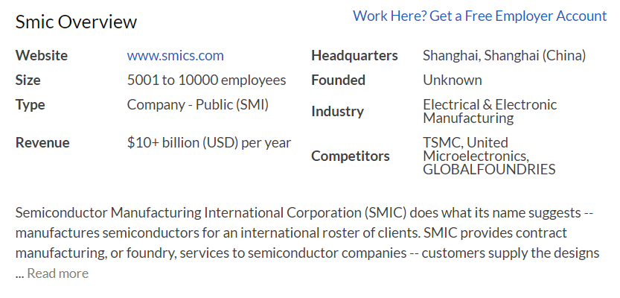

Pros

* 1. Good learning and skill development
  2. Largest in the mainland China and leading wafer foundry in China

Cons

* 1. Working culture is political
  2. Hardly have personal time and bad work life balance
  3. Less hand-on experts in advanced technology development program
  4. Low salary within the semiconductor industry

Insight

Requires better optimisation in management by structural conversation between teams.

Many Chinese companies compete in the global market by promoting cheap products compared to others. Regardless of the quality of the products, cheap products may not result in high revenue. Cheap product results in lower salary for employees too.

1. Samsung Electronics (Overall Rating : 3.5, 4800 Reviews)

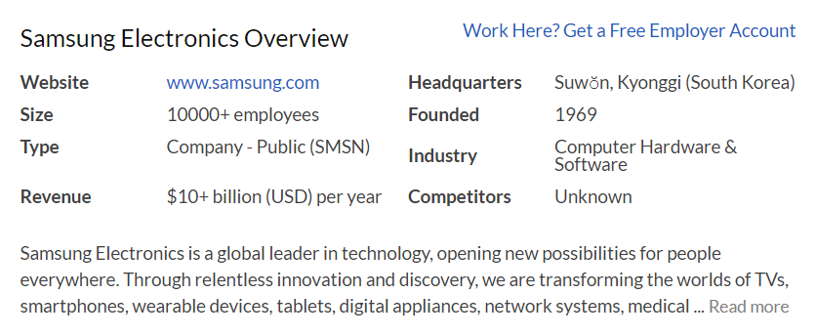

Pros

* 1. Good Salary. Highly merit based
  2. Trainings always available for the employee
  3. Great Talent pool

Cons

* 1. Long Working Hours. Work-life balance is not optimal.
  2. Strong Korean culture and strong dependent on headquarter in Korea

Insight

The strong Korean culture can result in the favouritism. Many employees may not have equal opportunity for their promotion. May result in strong politics.

Employees benefit greatly resulting from their high-performance rate. However, long working hours and high competition can cause burnt out. Paying high salary is not the only option for compensation. Alternative

1. SK Hynix (Overall Rating : 3.4, )

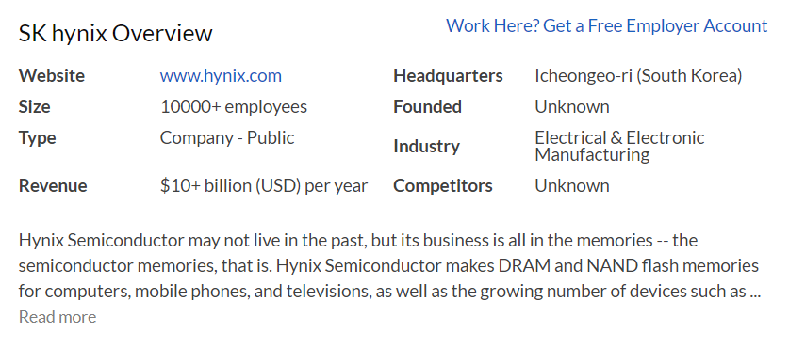

Pros

* 1. Great colleagues to work with and good culture & welfare
  2. Stable market position

Cons

* 1. Only few people involved in the decision-making process
  2. Location is not ideal (far from Seoul)

Insight

Employees generally experience less politics within the company. The prospective for the group’s future growth is promising, less uncertainty for their job position.

Employees with children, may have to live away from their family. Since the location is away from Seoul, high quality education and other infrastructures may not be available.

1. Micron Technology (Overall Rating 3.3, 1900 Reviews)

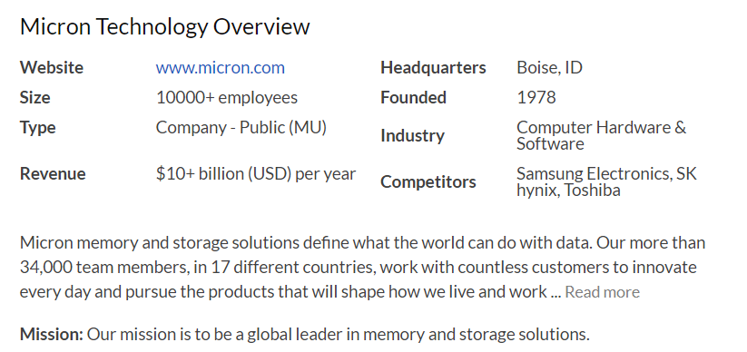

Pros

* 1. Great colleagues to work with and good culture
  2. Stable market position

Cons

* 1. Poor review on the management team
  2. Employees do not feel valued

Insight

Apart from the two Korean semiconductor companies, Micron Technology produced great output in the global market and managed to secure a stable market position. Further expansions in Asia market (such as in Singapore), can result in heavier workload.   
New policy (flexible) needs to be introduced to lift up stress.

Requires through evaluation and communication between management(executive) team and employee. Two parties have different interest in the company’s direction.

1. Intel Corporation (Overall Rating : 3.9, 12000 Reviews)

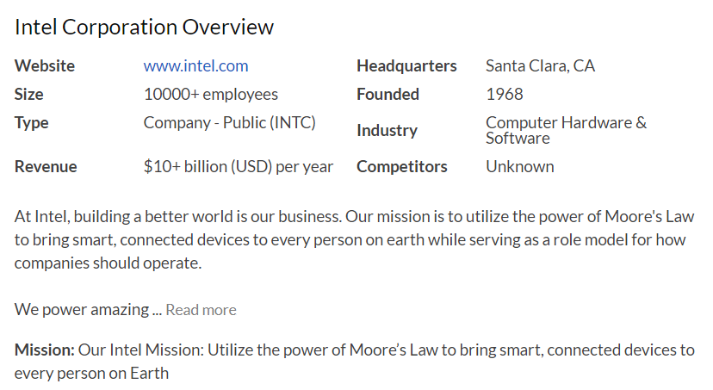

Pros

* 1. Easy to try different position and good work culture.
  2. Great welfare available. (free fruit, beverage / on site gym, medical, spa)

Cons

* 1. The company is too big to make voice
  2. Little innovation

Insight

The management team is spending reasonable resources to ensure the work life balance of the employees. Close community within the company can also be inferred.

Less voice can be made due to the large size company. Making simple business decision may take too much time.

With little innovation, employees with great vision and high expectation on their personal growth may leave or not join the company. This is the future task for the management team.